# Week 8.1

## Physics Component

* We need a new type of component to handle physics within the engine
* This component has two basic properties
  + Entity
  + Mass
* Entity is the BEPU type that will be placed into our simulation and will be responsible for relaying important information back into the rendering and decision making side of games

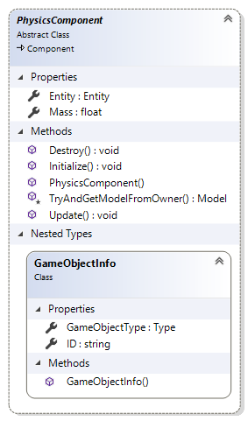

* GameObjectInfo will be used to identify our GameObjects when physics entities collide or we select and object via ray casting
  + ID and Type are the core identifiers we require
  + ID will allow us to get an object form the scene
  + Type will allow us make simple decision based on what type of game object was select/collided with

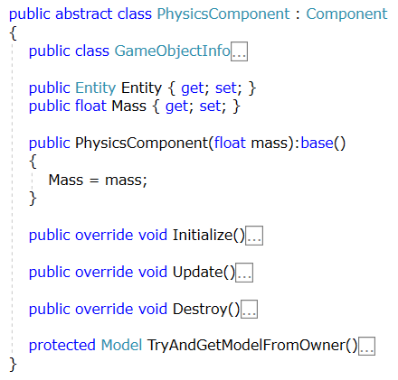

## Try And Get model From Owner

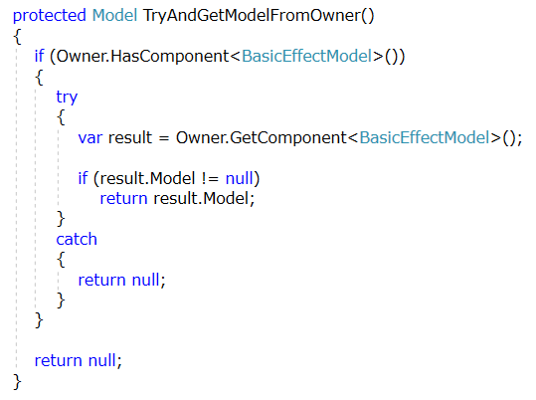

## Game Object Info Class

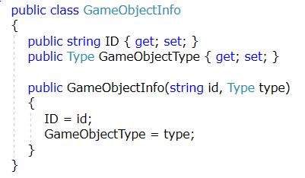

## Initialization

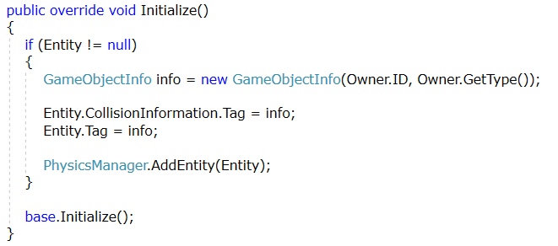

## Update

* In order to link the Rendering and Physics we must pass the transforms from the physics simulation to the Owner.World transform
  + If this is not done the rendering will never reflect changes done in the simulation
* Any object that has physics enabled will no longer be able to move using Owner.World matrix

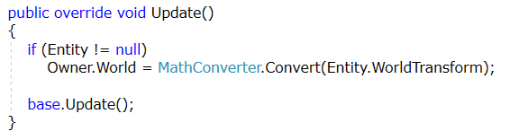

## Destroy

